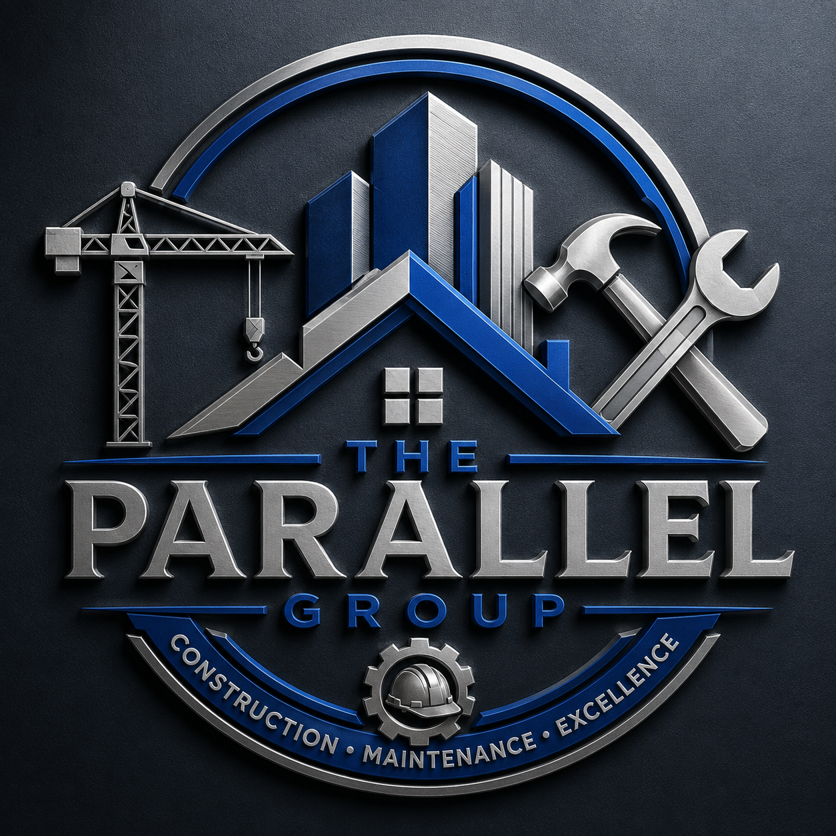

THE PARALLEL GROUP

Home Maintenance Membership

Membership Terms, Eligibility, Waiting Periods, Claim Limits & Exclusions

1. Eligibility
Membership is available to individuals and businesses that meet the following requirements:
- Applicants must be 18 years of age or older.
- The applicant must be the registered owner of the property or have written authority from the owner to enrol the property.
- The property must be situated within The Parallel Group's designated service areas.
- Membership fees must be paid in full and remain up to date.
- The property must be safe and reasonably maintained at the time of joining.
- The property may be subject to an inspection before membership is approved.
Eligible properties include:
- Freestanding houses
- Townhouses
- Apartments and flats
- Duplexes
- Holiday homes
- Rental properties
- Small business premises (where approved)

2. Membership Commencement
Membership begins once:
- The completed application has been accepted.
- The first membership fee has been received.
- Any applicable waiting periods have been completed.

3. Waiting Periods
To help prevent claims for pre-existing issues, the following waiting periods apply:
Benefit | Waiting Period
General Home Maintenance | 90 days
Plumbing Repairs | 90 days
Electrical Repairs | 90 days
Tiling Repairs | 90 days
Emergency Call-Out Assistance | 60 days
Additional Benefits | As specified in the membership schedule
No claims relating to incidents that occurred before membership commenced will be considered.

4. Claim Limits
Claims are subject to the member's selected membership option.
Example annual limits:
Basic Membership
- Maximum of 3 approved claims per year.
- Maximum annual benefit: R30,000.
Standard Membership
- Maximum of 6 approved claims per year.
- Maximum annual benefit: R75,000.
Premium Membership
- Maximum of 9 approved claims per year.
- Maximum annual benefit: R100,000.
The following may also apply:
- Maximum benefit per claim.
- Labour limits.
- Material limits.
- Annual benefit resets every 12 months while membership remains active.

5. Covered Services
Subject to the applicable membership plan, cover may include:

Plumbing
- Burst pipes
- Leaking taps
- Toilet repairs
- Blocked drains
- Geyser pipe repairs

Electrical
- Fault finding
- Plug points
- Light switches
- Circuit breakers
- Internal wiring repairs

Tiling
- Replacement of damaged tiles (subject to availability)
- Re-grouting
- Minor floor and wall tile repairs

General Maintenance
- Door repairs
- Lock replacements
- Minor carpentry
- Cupboard repairs
- Basic handyman services

6. General Exclusions
The membership does not cover:
- Pre-existing defects.
- Cosmetic improvements.
- Renovations or alterations..
- Wear and tear that does not require repair.
- Manufacturing defects.
- Damage caused by poor workmanship by third parties.
- Damage resulting from negligence.
- Abuse or intentional damage.
- Floods, earthquakes, storms, lightning or other natural disasters.
- Fire damage.
- Theft or vandalism.
- Pest infestations.
- Foundation movement.
- Structural defects.
- Building extensions.
- Roof replacement unless specifically included.
- Swimming pools.
- Boreholes.
- Solar installations unless listed as a covered benefit.
- Commercial machinery or industrial equipment.

7. Emergency Assistance
Emergency assistance is intended to make the property safe until permanent repairs can be completed.
Emergency services may include:
- Isolation of leaking pipes.
- Temporary electrical isolation.
- Temporary securing of damaged fittings.
- Making the property reasonably safe.
Emergency call-outs do not guarantee permanent repairs during the initial visit.

8. Claim Procedure
Members must:
- Contact The Parallel Group before arranging repairs on our Business WhatsApp
- Obtain authorisation before work commences, except where immediate action is required to prevent further damage.
- Provide photographs where requested.
- Cooperate with appointed contractors.
Unauthorised repairs may not qualify for reimbursement.

9. Member Responsibilities
Members agree to:
- Maintain their property in a reasonable condition.
- Report damage promptly.
- Prevent further damage where reasonably possible.
- Provide accurate information during the application process.
- Pay membership fees on time.

10. Cancellation
Members may cancel at any time by giving a 30 day written notice prior to cancellation request.
The Parallel Group may suspend or cancel membership where:
- Membership fees remain unpaid.
- Fraud or misrepresentation is identified.
- Membership terms are repeatedly breached.

11. Fraud Prevention
Claims will be declined where:
- False information is provided.
- Documentation has been altered.
- Damage has been deliberately caused.
- Multiple claims arise from the same undisclosed incident.
- Members attempt to obtain benefits dishonestly.
Fraud may also result in immediate cancellation of membership and recovery of costs where permitted by law.

12. Service Areas
Services are provided within approved operational areas.
Where no approved contractor is available, The Parallel Group may:
- Appoint an alternative contractor.
- Reschedule the repair.
- Offer reimbursement where approved in advance and supported by valid documentation.

13. Membership Renewal
Membership renews monthly, provided:
- Membership fees are received.
- The account remains in good standing.
- No cancellation notice has been received from either party.

14. General Conditions
- Membership is not transferable between properties unless approved by The Parallel Group.
- Benefits apply only to the registered property.
- Membership benefits cannot be exchanged for cash.
- The Parallel Group reserves the right to appoint its preferred service providers.
- All repairs are subject to the availability of contractors and materials.
- Certain repairs may require quotations or inspections before approval.

15. Customer Commitment
The Parallel Group is committed to providing members with professional workmanship, transparent communication, and reliable support. Our goal is to deliver practical home maintenance solutions that help protect your property and reduce the financial impact of unexpected repair costs.

